

NC2I-R
Coordination and Support Action
Co-funded by the European Commission under the
Euratom Research and Training Programme on Nuclear Energy
within the Seventh Framework Programme

Theme: FISSION-2013-2.4.1
Support to the emergence of a possible European Research Initiative on co-generation

Grant Agreement Number: 605167
Start date: 01/10/2013 Duration: 24 Months

D3.11 - Synthesis of the licensing procedures and main safety feedback gained on past projects and existing cogeneration facilities

Authors: O. Baudrand

NC2I-R – Issued on 06/03/2015 by organisation of first author

NC2I-R – Contract Number: 605167

Document title
Author(s) | O. Baudrand, Attila Kiss (BME), Christoph Pohl (TÜV Rheinland), Gerd Brinkmann (AREVA-D)
Number of pages | 33
Document type | Deliverable
Work Package | WP3
Document number | version n
Issued by | IRSN
Date of completion | 06/03/2015
Dissemination level | Restricted

Summary

In the framework of the FP7 NC2I-R project, the Working Package 3 (“WP3 - Safety and Licensing”) covers safety and licensing issues for future nuclear plants with cogeneration capability (heat and electricity production). The main objective of WP3 is to advise and support the definition of the general technical safety specifications of a future HTR demonstrator with a cogeneration capability.
The present report is the first WP3 deliverable and makes a synthesis of the elements related to safety and licensing of nuclear installations which are performing or have performed cogeneration. These elements have been gathered by mean of questionnaires sent to nuclear operators and of selected published works dealing with past projects of nuclear cogeneration. This report shall also serve as a basis for the task of the WP3 dealing with the tentative planning for safety and licensing process applicable to a futur nuclear cogeneration system.

Approval

Version |  | First author | WP leader | Project Coordinator
0 |  | O. Baudrand, IRSN | O. Baudrand, IRSN | K. Rozycki, NCBJ
 |  | 06/03/2015 | 06/03/2015

Distribution list

Name | Organisation | Comments
P. Manolatos | EC
All beneficiaries | NC2I-R | Through internet workspace

Synthesis of the licensing procedures and main safety feedback gained on past projects and existing cogeneration facilities

Rapport n° PSN-SRDS/SNR/2015-00010

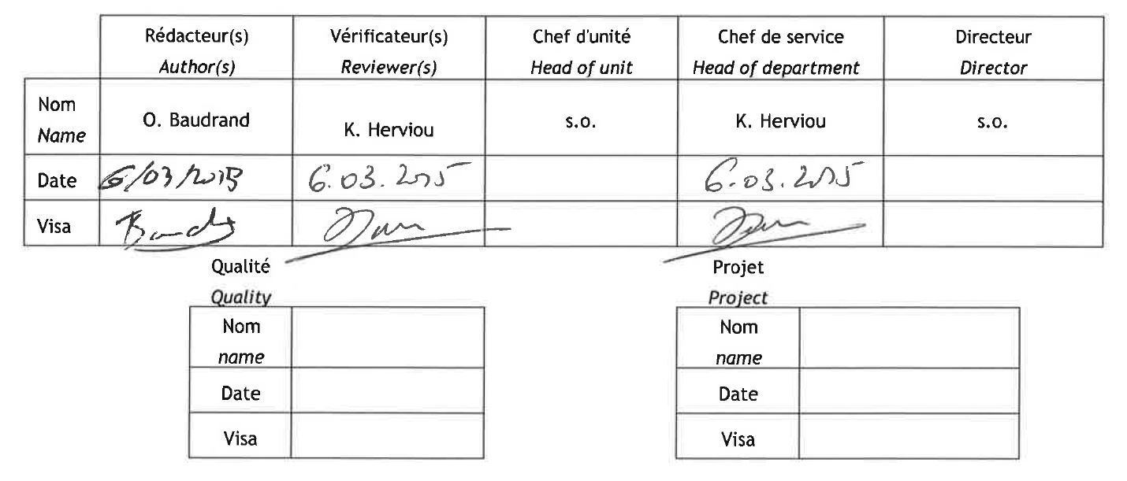

Title: Synthesis of the licensing procedures and main safety feedback gained on past projects and existing co-generation facilities

Auteur/author(s) O. Baudrand
Contributors : Attila Kiss (BME), Christoph Pohl (TÜV), Gerd Brinkmann (AREVA-D), Pierre-Marir Plet (EON)

Type de document :  Document type : | Report | Date de diffusion :  Distribution date :
Référence(s) : |  | E-mail de l'auteur : | Olivier.baudrand@irsn.fr
Elément DPPA

Mots-clés (Max. 5) :
Key-words (Max. 5): | Nuclear cogeneration, high temperature reactors, licensing feedback

Resume
Dans le cadre du projet européen NC2I-R (FP7), le groupe de travail n°3 (« WP3 – Safety and licensing ») traite des questions de sûreté et de certification des futures centrales réalisant de la cogénération nucléaire (production de chaleur et d’électricité). Le travail du WP3 porte en particulier sur les exigences de sûreté associées à un réacteur de démonstration du concept HTR appliqué à la cogénération, en tenant compte des spécifications techniques et de sûreté qui sont définies par ailleurs dans le projet NC2I-R.
Le présent rapport est le premier livrable du WP3 et fait la synthèse des informations relatives à la sûreté et à la certification d’installations nucléaire qui produisent ou ont produit de la chaleur et de l’électricité. Ces informations ont été recueillies au moyen de questionnaires envoyés à des exploitants. Il s’appuie également sur le retour d’expérience d’anciens projets. Les conclusions du présent rapport serviront de base à l’analyse du processus de certification tel qu’il pourrait s’appliquer à un futur démonstrateur et qui sera développée dans le livrable D3.2.

Abstract
In the framework of the FP7 NC2I-R project, the Working Package 3 (“WP3 - Safety and Licensing”) covers safety and licensing issues for future nuclear plants with cogeneration capability (heat and electricity production). The main objective of WP3 is to advise and support the definition of the general technical safety specifications of a future HTR demonstrator with a cogeneration capability.
The present report is the first WP3 deliverable and makes a synthesis of the elements related to safety and licensing of nuclear installations which are performing or have performed cogeneration. These elements have been gathered by mean of questionnaires sent to nuclear operators and of selected published works dealing with past projects of nuclear cogeneration. This report shall also serve as a basis for the task of the WP3 dealing with the tentative planning for safety and licensing process applicable to a futur nuclear cogeneration system.

Historique des modifications/Change history

Indice de révision  Revision | Date | Auteur  Author | Pages ou paragraphes modifiés  Pages or paragraphs changed | Nature des modifications  Nature of the changes
1 | 19/12/2014 | O. Baudrand |  | Integration of partners comments (TUV, AREVA, EON, BME)
2 | 08/01/2015 | Id. |  | Review by K. Herviou
3 | 02/02/2015 | Id. |  | Remarks from Halden integrated
4 | 06/03/2015 | Id. |  | Final review by K. Herviou

Table of contents

Table of contents 6
1 Introduction 7
2 Feedback of cogeneration with nuclear power plants 7
2.1 Methodology 7
2.2 Installations reviewed 7
2.3 Facilites and projects for district heating 13
2.3.1 District heating with the Beznau PWRs 15
2.3.2 THERMOS project: a nuclear installation dedicated to district heating 17
2.3.3 NHR-5 an experimental reactor for district heating 20
2.3.4 Conclusion on nuclear district heating experience 20
2.4 Process heat production 21
2.4.1 The Halden experimental reactor 21
2.4.2 Stade NPP 22
2.4.3 Cogeneration with HTRs: the PNP and HTR-Module projects 23
2.4.4 Conclusion on HTR feed-back for cogeneration 27
2.5 Synthesis 27
2.5.1 General principles 27
2.5.2 Feedback synthesis 28
3 Conclusion 30
4 Acronyms and definitions 32
APPENDIX I: Extract form the questionnaire on nuclear cogeneration projects – Questions related to safety and licensing 33

Introduction
Future high temperature reactor (HTR) projects would include the potential for cogeneration of heat and electricity. Together with technical challenges, such option might induce safety and licensing issues. To tackle this question, a first step consists in investigating the existing experiences, as nuclear cogeneration has already a long history in Europe. Thus, the present report provides a synthesis of the feed-back of nuclear cogeneration, in the domains of safety and licensing. It is based on a selection of currently operating installations and past “paper” projects.

Feedback of cogeneration with nuclear power plants

Methodology
The first step of this work consisted in collecting information on nuclear installations which are or were operating in a cogeneration mode for industrial or domestic purposes. Project plants have been also examined, as far as information was available on how their designers dealt with safety issues related to cogeneration during the initial licensing phases. The data were collected by mean of a questionnaire written in collaboration with the work package number 2 (“Infrastructures and competences”) and sent to selected operators and plant designers. The written answers have been completed, as far as possible, by mean of onsite interviews and personal contacts.
The questionnaires sent to operators and plant designers cover topics ranging from financing to operational organization, public relations and safety. The questions related to safety are listed in the appendix I. The objective of these questions was to investigate the way the operators have assessed the safety of the cogeneration installations and how this work has been integrated to the licensing procedures of the NPP.
We have distinguished between NPPs with genuine cogeneration capability and those for which cogeneration was implemented after the start-up (sometimes several years after). For the latter, the cogeneration induced some plant technical modifications and installation of additional equipment. Usually, the “product” of the cogeneration installation is a heat carrier fluid which is sent out of the plant site, to customers (industries, district heating grids, etc.). So, the requirements on cleanliness the delivered fluid have been also investigated. Finally, we have asked about the global impact of cogeneration on the environmental footprint of the NPP, because safety is a part of the general objective of sustainability prone by the generation four initiative.
In addition, data have been gathered from publicly available works on nuclear cogeneration. Indeed, since many years, the IAEA is conducting a considerable work on nuclear heat application (ref.1 and ref.4)..
In a second step, answers to questionnaires and the other data collected have been analyzed to determine a trend in the licensing of nuclear cogeneration plants. Finally, by comparison with already existing installations on LWR facilities, we examined the potential impacts of the HTR specific technology and temperatures on safety assessment of the cogeneration system.

Installations reviewed
For this study, 10 nuclear cogeneration plants have been reviewed on the basis of the answers to the questionnaire elaborated by the WP2 and WP3 partners. Past projects have been also examined.
An abridged description of these installations and engineering projects is given in the following table.

Nuclear plants
Plant | Life time | Reactor | Country | % of tot. th. power | Technology for heat production | Purposes | Comments
Beznau | 1969 - | PWR  2 units  380 MWe | Switzerland | ~3.5% | Steam bleed from turbines  Heat exchanger secondary/tertiary circuit  Closed tertiary circuit  Max heat prod.: 80 MWth  T_{out}=126°C (max.), T_{in}=85°C (hot water) | District heating (private and industry customers) | 11 municipalities connected to a main grid with a length of 31 km
Stade | 1972 - 2003 | PWR  630 MWe | Germany | ~2.5% | Steam bleed from turbine  Closed tertiary circuit between the NPP and the salt works  Max heat prod.: 48 MWth  T_{out}=190°C, P=0,65 MPa (steam)  T_{in}=145°C (condensates from salt works) | Steam production for desalination  Steam feed of an auxiliary power plant | Steam production from 1984 to 2003  Site now under decommissioning
Bohunice-V2 | 1984 & 1985 | VVER-440/V213  2 units  505 MWe | Slovakia | 8% | Steam bleed from turbines  Heat exchanger between secondary/tertiary circuit  Closed Tertiary circuit  Max heat output capacity: 240 MWth (at heat feeder)  T_{out}=140°C, T_{in}=70°C (hot water) | District heating (houses, industry, schools, hospitals, offices) | Each nuclear unit can provide 100% of the standard heat production.  Offtakes from the turbine is a standard option in VVER-440  Distance from housing ~5 km (Jaslovské Bohunice village)
Paks | 1982 - 1987 | VVER-440/V213  4 units  500 MWe | Hungary | ~3% | Steam bleed from turbines  Output: 42 MWth  T_{out}=130°C, T_{in}=70°C (hot water) at 8/9 bar | District heating (housing blocks) | No need for back-up.  Only one unit used for heat production
Temelin | 2000 &2002 | VVER 1000/V320  2 units (2x1000 MWe) | Czech Republic | ~10% | Steam bleed from turbines  Heat exchangers between secondary/tertiary circuit  Closed tertiary circuit  Max. heat output capacity: 300 MW/turbine  T_{out}=90°C to 130°C, T_{in}= 50°C to 90°C (hot water) | District heating | Each nuclear unit can provide 100% of the standard heat production  District heating for Týnnad Vlatvou (5 km)
Halden | 1959 | HBWR  20 MWth | Norway | 100% | Steam generator (tertiary circuit) | Process steam | Experimental reactor moderated by heavy water  Process steam delivered to a paper mill
Ågesta R3 | 1964 - 1974 | PHWR  12 MWe | Sweden | - | Hot water heated by the condenser (tertiary circuit)  T_{out}= 80°C to 120°C, T_{in}= 60°C | District heating | Prototype reactor moderated by heavy water
NHR-5 | 1989 - | PWR  5 MWth | China | - | Hot water: T_{out}=90°C T_{in}=60°C  Grid pressure : 0.6 MPa | District heating (in winter)  Cogeneration of electricity from 1991 | Experimental reactor at INET (Tsinghua University)  Demo plant of a 200 MWth project operated only for short periods of experimentation

Projects of cogeneration plants
Plant | Reactor | Country | % of tot. th. power | Technology for heat production | Purposes | Comments
Loviisa 3 | PWR or BWR  1 unit | Finland | - | Steam bleed / special adaptation of turbines needed  Closed tertiary circuit  Max heat output capacity: 1000 MW  T_{out}= 120°C, T_{in}= 54°C (not optimized) | Electricity and district heating | Large scale heat production  Large expected impact in waste heat reduction to the environment
PNP-200 | HTR  2x200 MWth | Germany | - | Primary helium used in steam reformer (T_{in}= 950°C, T_{out}= 680°C)  Steam reformer integrated to the primary circuit | Process heat and steam for coal conversion | Original PNP designs up to 3000 MWth
HTR-Module | HTR  170 to 250 MWth / module | Germany |  | Original design: 2x200 MWth, secondary steam : 19 Mpa / 525°C  Adaptations (examples):  - 1x170 MWth (BEB)  - x 200 MWth, 1.6 MPa/539°C, electriciyty: 80.7/77.7 MWe (HOECHST)  - 4/3x200 MWth, 3.2 MPa/380°C, electricity 89.7/71.7 MWe (BAYER)  - 4x200 MWth, 1.8 MPa/265°C, electricity 160/137.5 MWe (BASF) | Steam and electricity for refinery (BEB), chemical plants (BASF, BAYER, HOECHST, etc.) | Several adaptations of the initial concept to fit the end users demand
THERMOS | Water pool reactor | France | 100% | Hot water at low pressure  T_{out}= 80°C to 120°C, T_{in}= 60°C | District heating only | Technology derived from experimental reactors (reactor vessel in a pool, plate type fuel, etc.).

Table 1: characteristics of the reviewed nuclear cogeneration facilities and projects

Facilites and projects for district heating
General features
Most of the cogeneration systems in operation at present are producing low temperature steam (around 200°C) or hot water (around 120°C) as requested for district heating applications. The heat carrier fluid is delivered to end users by a pipe grid which usually extends over à medium size city or several villages (like in the area of Beznau in Switzerland). Some industry end users may also be connected to the heat grid, together with private consumers.
Implementing the production of low temperature heat is not technically challenging for existing PWRs. In practice, steam is extracted from the secondary circuit and directed towards a “station” housing heat exchangers (as an example: the “boiler house” in Stade). As NPPs are not located near the customers, it is usually necessary to build a connecting pipeline between the main station and the district heating grid. A heat exchanger is implemented between the secondary circuit and the connecting pipeline (MEHS on the Figure 2). Finally, private installations are also connected to the grid via a heat exchanger (LEHS). The main heat exchanger (MEHAS) is usually located inside the nuclear site fence as it receives secondary steam: secondary circuit is preferably enclosed in the nuclear plant area as it is subject to specific controls and might be contaminated by primary leaks (despite isolation systems).
The location of the bleeding points, and therefore the pressure and temperature of the steam, depends on the turbine technology. As an example, with condensation turbines, the simpler way is to extract the live steam before the turbine inlet. It is to be noted that many PWRs are already operating with steam extraction before the turbine, even without cogeneration option. This is the case on the nuclear plants operated by EDF, for which live steam is extracted before the turbines for comfort heating of the installation and to feed auxiliary steam circuits. Steam turbines adapted to cogeneration are fitted with taps located between high pressure and low pressure body. Steam can also be extracted at the outlet of the so called “back pressure” turbines, where pressure is higher than that obtain with the condensation turbines.

Secondary circuit

Figure 1: typical layout of low temperature steam production (ref.2)
Heat demand is seasonal (for private consumers) but, in most of the cases examined here, the amount of heat extracted for district heating remains modest (in general less than 10% of the thermal power of the reactor). So the variation in the demand does not disturb the plant control, even if it is operated in a base load mode.
It is worth noting that the data collected do not indicate any relation between the cogeneration installations and the emergency planning zones.
District heating with VVER
A significant number of nuclear cogeneration facilities based on the VVER technology have been built in the countries members of the former Soviet Union. For these NPP (see Table 1), the delivered water is heated by the steam extracted from the turbine.
As regards the licensing, the procedures applied in those times were not detailed in the answers to the questionnaires (suppose that they have been documented). As an example, cogeneration capability has been implemented from the start-up of Paks NPP (Hungary) and the licensing aspects link to the cogeneration were not handled separately of the general licensing of the plant. The heat production capability was not taken into account in the safety report of the NPP and there is no specific initiating event to be considered for the safety assessment. According to the operator, if radioactivity was detected in the secondary circuit, this would initiate a SCRAM of the reactor. The operator also mentioned that the environmental footprint of the NPP has not been significantly influenced by the heat production.
Nevertheless, some of these installations recently underwent safety periodic reviews (sometimes in the frame of European Union’s programs). So, the technical measures taken to ensure the safety of the delivered heat are at least of interest because they may be compatible with the current safety requirements in the host countries.
For district heating, the main concern is to ensure the protection of the Public. Simple technical measures were implemented on these VVER plant to achieve this goal. One of the principles applied is to ensure at least three barriers between the fuel and the delivered fluid, two of which are heat exchange devices (heat exchangers or boilers if steam is delivered to the grid). The heat delivery circuit is usually a closed circuit. This means that, apart from the main heat exchange station between intermediate and delivery circuits, sub-stations or private stations (in the private houses or blocks) are established on the grid to connect end users. These principles are illustrated below on the Figure 2 which represents the arrangement of Trnava (Slovakia) district heating circuits connected to Bohunice V2.

Figure 2: schematic of the heat delivery circuits associated with the Bohunice V2 power plant

Usually, in VVER installations, the pressure of the fluid delivered to customers is maintained higher than the pressure of the secondary steam (i.e. on figure 1, P_{circuit 3} > P_{circuit 2}) in order to ensure a “pressure” barrier. As an example: a minimum of 0.1 MPa overpressure is recommended in Russian regulation. To further prevent downstream radioactive contamination in an accident situation, the heat exchanger (MEHS on figure 1) can be isolated.
In LWRs, the operator has to continuously monitor the radioactivity level in the secondary circuit (ref. 15) this is also important if cogeneration is implemented on the plant. This monitoring can be applied to the delivered fluid as well. This control is performed at the outlet and inlet of the main heat exchanger station (circuit 3 on Figure 2), but it is not always the case in existing cogeneration installations. As an example, the radioactivity of the secondary circuit is monitored in Paks, but there are no radiological criteria for the delivered water: the applicant indicates that if an abnormal level of radioactivity is detected in the secondary circuit, the reactor would be shutdown automatically (no information on radioactivity limits in the secondary circuit has been provided in the questionnaires).
Anyway, it sounds obvious that the operator of the main heat station should be able to guarantee the chemical and radiological quality of the delivered fluid, meaning some controls to be done. Condensates driven back to the plant by the heating grid could also be polluted because of malfunction of the domestic installations connected. Therefore this could damage the heat exchangers of the main heat station. This is why, in several installations, controls are performed on the fluid of the heat grid which is equipped with isolating devices located at the inlet and outlet of the main heat exchanger station.
Finally, the global review of the questionnaires related to VVERs (Paks, Temelin and Bohunice) has revealed no impact of the heat production on the plant safety. One must note that, some of the plants reviewed are not monitoring the delivered fluid. In practice, the quality controls (chemical and radiological) on intermediate and delivered fluid are not performed with the same purpose. The nuclear plant operator has to control the integrity of the second barrier by radiological and chemical monitoring of the secondary fluid. The secondary circuit must also be isolable, because it crosses the reactor containment. These are common safety provisions for the reactor itself. In the case of the co-generation, it seems obvious that the plant operator should be able to justify the good quality of the fluid delivered to customers. Moreover, it could be mandatory to monitor the radioactivity level of the delivered fluid, as it is done for any other kind of materials or substances which can go out of the site fence. This could be seen as a part of the environmental monitoring performed in the vicinity of the nuclear plant. This is why, the radiological monitoring of the delivered fluid, as performed in several nuclear co-generation plants should certainly be applied to new projects. This monitoring should be fast enough to allow for appropriate counter measures to be set up as closing the delivery pipe.

District heating with the Beznau PWRs
The Beznau nuclear site (Figure 3) hosts two PWR units of 380 MWe, which were commissioned in 1969 and 1971. The units are operated in a base load mode. Heat production has been implemented 30 years ago, after the start-up of the reactors (ref.5). The district heating grid connects around 2500 customers (ref. 6 in the vicinity of the plant (housing and industries). The maximum potential heat delivery is 80 MW, but usually it varies seasonally between 60 MW and a few megawatts (in summer).
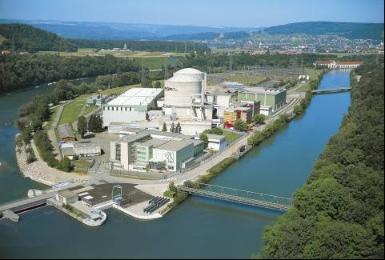
Heat transfer pipes

Figure 3: Beznau PWR units

The Figure 4 below shows the circuits arrangement in the Beznau units: it is a typical layout for heat district production with a PWR. It is to be noted that the two units of Beznau are connected to the heat grid which allows a high availability despite maintenance or refuelling periods (probably also in case of unplanned outage - but this latter aspect was not confirmed). Steam is extracted on crossover pipes between high and low pressure turbines at a temperature of 122°C/128°C and a pressure between 0.22 MPa and 0.28 MPa, depending of the demand, and directed to two heat exchangers in parallel (only one is normally in operation). The water delivered to the grid by the central pumping station is heated between from 85°C to 126°C (max.) at a pressure of 1.6 MPa.
The heat production represents a small portion of the thermal power of the nuclear units (around 3.5%) and only an 8 MW cut-off in the electricity production (for a maximum 80 MW of heat production). This is why the heat production improves slightly the use of the fuel.
16 bar /120°C
1-6: Primary circuit 18: Moisture separator reheater
7: Steam generator (barrier n°2) 19: Steam bleeding for cogeneration
7- 18: Secondary circuit 20: REFUNA heat exchanger (barrier n°3)

Figure 4 : schematic layout of the Beznau plant

The closed heating grid makes a pipeline “backbone” of 31 km (Figure 5) connected to a distribution grid of more than 100 km. Several back-up boilers installed on the grid may take over the heat supply during simultaneous outages of the reactors.

Figure 5: heating grid of Beznau

The heated water quality monitoring does not include radiological measurements. Nonetheless, to ensure that the delivered water cannot be contaminated by water of the secondary circuit in case of heat exchanger leak, the pressure inside the heat grid (tertiary circuit) is kept “strictly higher than the pressure in the crossover pipes of the turbines” (ref. 5). To achieve this in all situation, the heat delivery circuit can be isolated by two groups of safety valves located on outlet and inlet pipes: the automatic closure of these valves in case of inadvertent loss of pressure in the heat grid ensure that a minimum pressure of 0.6 MPa is kept at the secondary side of the heat exchanger. The valves are tested periodically. It is also worth noting that customers are usually connected to the main heat grid with their own heat exchanger. Given these provisions and according to the operator, there was no specific licensing update linked to the implementation of the cogeneration facility because the operator has not identified potential safety cases induced by this facility.
From the environmental point of view, district heating feed-back in Beznau is undoubtedly positive because:
- the 142 GW.h sold each year save around 46,000 tons of CO2, compared with oil fed boilers (ref.6);
- the truck traffic for oil supply has been reduced by almost 8500 trips;
- a large percentage of heat extracted of the turbine would instead have been discharged to the river Aare (impact more or less important depending on the initial temperature of the river).
Finally, Beznau NPP can be taken as a good example of regional district heating, where the heating station is technically decoupled from the reactor. This heat production mode appears to have no significant impact on the operation or the safety of the units. Of course, Beznau reactors were built in a relatively low populated area but relatively close to Zurich (370,000 inhabitants), enabling a reasonable distance between the heat station and the consumers (35 km).

THERMOS project: a nuclear installation dedicated to district heating
As in many developed countries, France has been severely hit by the oil crisis of the mid-seventies. The answer was an unprecedented plan for nuclear electricity development and, in this favourable environment, the use of nuclear reactor for district heating has also been explored.
The THERMOS project has been developed by the French company TECHNICATOME in the mid-seventies. It is an example of reactor dedicated only to heat production at low temperature (around 120°C), well adapted to district heating or desalination. Although this project was not a co-generation facility, it seems relevant for the present study as we want to consider the specific safety and licensing issues stemming from the connection to a public heat grid (in that sense, THERMOS is comparable to the Halden reactor).

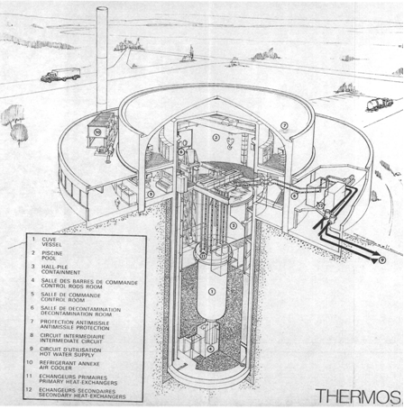
1 Vessel
2 Pool
3 Containment
4 Control rods room
5 Control room
6 Decontamination room
7 Antimissile protection
8 Intermediate circuit
9 Hot water supply
10 Air cooler
11 Primary heat exchangers
12 Secondary heat exchangers
13 isolation valves
9
6
12
8
7
11
2
4
1
10
5
3
13

Figure 6: the THERMOS project

Initially, THERMOS was to be built in Saclay, near Paris. In May 1976, TECHNICATOME submitted a “General safety options report” to the “Commission de Sûreté des Piles” (CSP), a commission of CEA experts. The CSP issued several recommendations in October 1976. Short after this first review, the THERMOS project underwent substantial technical modifications to increase the outlet temperature of the delivered water from 100°C up to 120°C. A complementary report was then issued in 1977 and examined in the same year by the CSP.
The recommendations of the CSP should have been taken into account in the preliminary safety report and presented to the approval of the safety authority (which was, at that time a, department of the ministry of industry). Before that step, the project was abandoned shortly after 1977. In 1979, the CEA center located in Grenoble, together with the city authorities took over the THERMOS project with the goal to supply the city heat grid. But, due to technical issues and unfavorable political environment (competition with coal mines near Grenoble and other projects, etc.), THERMOS was definitely abandoned in 1981.
THERMOS was a pressurized water cooled reactor of 100 MWth designed to deliver hot water for housing. A back up boiler was intended to cope with seasonal peaks of heat demand. In the documents reviewed there were no elements on the way to adapt the reactor heat production to the variations in consumer demand.
The reactor core would have been loaded with oxide fuel enclosed in zircaloy plates. The diameter of the core vessel was around 6 m, containing the primary pumps and heat exchangers. The pressure of the primary circuit was 0.8 MPa. The stainless steel vessel, containing the core, was anchored down in a water pool and equipped with check valves. An intermediate circuit (two loops) takes place between the primary circuit and the heating grid as shown in the scheme of the Figure 6. The water of the heat delivery circuit was heated up to 120°C (100°C in a first version). Two isolation valves are located on each branch of the tertiary circuit, on each side of the reactor hall.
The main safety concern for this project was the settlement of nuclear reactor in a suburban area. The rationale for this choice was based on the economics of heat transport, which were at that time badly influenced by the length of the connection between the reactor and the consumer grid. In particular, designers were concerned by the risks potentially induced by the nuclear plant industrial environment (especially in Grenoble, were chemical facilities were settled in the suburbs). To cope with this issue, a comprehensive review of external hazards, including malevolence, was carried out in order to design the reactor. As regards the risks for the public, the designers have outlined the limited nuclear power of THERMOS, which would result in much lower accidental releases than a standard PWR (900 MWe units at that time). This explains also why this SMR option had been chosen, in comparison with connecting a PWR to a heat grid. So, in relation with the major concern of radioactive materials confinement, the following safety options were envisaged in the project:
- fission products retention in the fuel (low temperature of oxide fuel – 400°C to 850°C),
- no diluted boron in the primary water (limits the tritium production),
- primary water continuous filtration (resins),
- “clean reactor” option: in case of clad rupture, the reactor is shut down and the faulted assembly is removed from the core (detection and screening of clad rupture by delayed neutron detectors connected to the protection system),
- intermediate circuit with higher pressure than that of the primary circuit (“pressure barrier”) and equipped with two isolation valves,
- confinement in a pressure resistant reactor hall (possibility of pressure limitation by filtered releases to the atmosphere),
- gaseous leaks from the reactor hall collected in the space between the double wall containment and filtered before exhaust,
- underground settlement of the reactor pool with an antimissile enclosure.
As regards the first point above, the choice of the plate type fuel called CARAMEL was partially linked to the goal of limiting the risk of radioactive contamination of the primary circuit in case of clad flaws. The fuel was to be divided in squares laminated between two zirconium alloy plates (like toffees). So, in case of clad flaw, only a limited amount of fission products would have been released in the primary water.
It is also worth noting that the “vessel in pool” design allowed for core cooling by natural convection with the pool water (800 m³) in case of loss of external energy supply or loss of the heat sink. In such accidental scenarios, passive systems were able to equilibrate the pressures in the pool and the primary circuit, so the check valves would open and connect the vessel internal volume to the pool. The pool was cooled by an “ultimate cooling circuit” (cold water).
Given the relatively low power of the core, these safety options would have resulted in long grace delays in case of accidents: several hours or even days were targeted. Without depressurization of the primary circuit, the objective was to remove the residual heat through the vessel wall.
After the two reviews performed by the CSP, some recommendations were issued which were directly or indirectly linked to the safety of the heat production; they addressed the following items:
- permanent monitoring of the leak tightness of the intermediate circuits,
- permanent radioactivity monitoring of the intermediate water,
- installation of two safety classified isolation valves (one inside the reactor hall, the other outside) on each branch of the intermediate circuits,
- permanent radioactivity monitoring of the hot water delivered to the grid,
- provisions to ensure the efficiency of the air filters of the ventilation system in case of fire in the back-up station (oil or gas fired back-up station),
- provision to prevent toxic gases ingress in the reactor hall or in the control room.
In addition several recommendations addressed the robustness of the plant to malevolence.
Finally, it is noticeable that the intended location of the reactor, in a suburban area, led to stringent safety requirements as compared with those imposed to PWRs at that time.
In 1977, the CSP did not really handle the issue of siting. In practice, the designer did not want to set up siting criteria at that early stage of the project because THERMOS was proposed for different potential applications and site locations.
Before the abandon of the project, the necessity of a huge experimental program was outlined. In particular the specific plate type fuel envisaged needed qualification. Similarly, the accidental analyses made for the pre-design phase were to be developed.
Anyway, considering the evaluations made at that time, the radiological consequences for the public in case of core melt (with very penalizing assumptions) would have been much higher than the actual limits. Nevertheless, the R&D program would have had to address this issue to investigate the potential for a more realistic safety case.
Obviously, even if the technology and standards of THERMOS are now obsolete, the recommendations, the principles from which they derive and the way the applicant has taken into account natural and human hazards would be a good starting point to establish safety requirements.

NHR-5 an experimental reactor for district heating
Unlike THERMOS remained a paper project, the Nuclear Heating Reactor concept (NHR) originally developed by Siemens-KWU, has been built in China at the Tsinghua University (ref.7). The NHR-5 (see Table 1) is an experimental facility build as a demo plant of the 200 MWth NHR concept. The idea of the promoters was to impulse the development of nuclear district heating in China, but as far as we know, no city has applied to build such facility. Since 1991, a steam turbine has been connected to a stream generator for electricity cogeneration. According to the operator, the availability of the plant has been near 100% at least for the first three winters (ref.7).
NHR-5 is a pressurized water reactor of integrated design dedicated to hot water production for district heating. The few elements reviewed, related to design and operational safety, come mainly from publications, but several engineering features are worth noting, which denote a similar approach as compared with THERMOS:
- Emphasis has been put on inherent safety by:
  - relying on natural circulation in the primary circuit,
  - limiting the core power density and the residual heat in relation with the thermal inertia bring by the primary water so no emergency cooling system would be needed,
  - relying on neutron feedback coefficients able to shut down the core in case of failure of the emergency control system.
- Close containment build around the reactor vessel to avoid core uncovering
- An intermediate circuit provides separation between heat delivery circuit and the primary circuit; pressure in the intermediate circuit is higher than in the primary circuit.
According to the operator (INET), the NHR-5 has been licensed according to classical procedures used for PWRs in China, without specific work to assess the cogeneration capability.
What is important to note, is the attempt to preclude the core uncovering and, consequently core melting, for these reactors intended for use in suburban areas (including the 200 MWth version). The approach based on power limitation, passive heat removal, enhanced thermal inertia is comparable with the one applied in the design of HTR concept.

Conclusion on nuclear district heating experience
As a conclusion, the common feature between the existing cogeneration systems used for district heating is the physical decoupling between the heat delivery circuit and the reactor. This decoupling is linked to some basic principles of physical separation ensured by an intermediate circuit, isolation devices and thermal inertia of the grid.
The proportion of diverted heat to the grid remains modest in general, which account for no significant modification of the plant monitoring (even in base load mode).
As for common installations, influence of the environment and external risks sensitivity has sometimes been studied. However, the questionnaires and interviews have revealed no specific safety issues or past incidents link to the cogeneration capability. Apparently, safety analyses have not led to include specific safety cases in the reference documents of the plants (safety report).
Nevertheless, it is worth noting that there were attempts to design SMRs able to be installed in suburban areas, in order to reduce the cost of the intermediate pipeline connexion between the NPP and existing urban heat grids (THERMOS, NHR). This led to concepts rather similar, in their goals, to the HTR.

Process heat production
Up to now, only few nuclear plants have produced or are producing heat for the industry. In our study we have considered the Halden experimental reactor, the STADE reactor and the projects carried out in Germany in the 80s (prototype nuclear process heat project – PNP – and HTR-Modul).

The Halden experimental reactor
The Halden facility is a Heavy Boiling Water Reactor (HBWR) located close to the sea shore in the south-east of Norway. The reactor vessel and primary circuit are enclosed in an artificial rock cavern.
The reactor is operated by the Norwegian Institute for Energy Technology (IFE) and used as the main experimental device as part of the international OECD Halden Reactor Project for research on nuclear fuels and materials. The Halden reactor has been operated on a regular basis since 1959. It is also delivering steam to a paper factory, but R&D activities are prevailing on heat production.
The nuclear plant comprises a reactor pressurized vessel and three water/steam circuits. The cooling medium in the reactor vessel is heavy water, which circulates in a closed circuit within the containment. The energy carried by the primary coolant is transferred by steam transformers to a secondary closed circuit containing light water (Figure 7). The pipes transporting the secondary circuit pass out of the containment, transferring the heat to a tertiary light water circuit connected to the neighboring paper factory.

Figure 7: Halden reactor schematic flow sheet (ref.9)

Halden reactor is an exception among the cogeneration systems examined here, because all the produced heat (around 20 MW) is delivered to the paper mill, although this represents a maximum of 10% of the paper mill’s need. The majority of the process heat is produced by conventional boilers which serve also as back-up. So the industrial process does not request the reactor availability, which is imposed by the experimental programs.
According to the operator, at the time of the licensing of the reactor, there was no specific safety assessment required because of the steam production. Of course, since the commissioning, the installation underwent several safety reassessments (documents are not publicly available). We consulted the report of the IAEA INSARR mission which took place in Halden in 2007 (ref.10). As a follow up of this mission, an important upgrade of the SAR has been done by IFE, but the recommendations and comments made by the IAEA reviewers were not related specifically to the heat generation for the paper mill.
It is worth noting that the reactor is enclosed in an artificial cave which plays the role of a containment barrier and a physical protection in case of external hazards. Moreover, in case of loss of condensate from the paper mill, a diverse water supply can be established by a connection to the community water grid. And, in case of unexpected perturbation of the normal cooling, the reactor heat would be damped to the nearby river. In those cases, the reactor would be automatically scrammed and residual heat removed by dedicated systems. So the main safety concern is the confinement of radioactive elements carried by the heavy water. The quality of the primary heavy water and secondary light water is monitored by detection of gamma emitters, leading to further water analysis if an alarm value is reached (no automatic isolation of the tertiary circuit on abnormal activity detection). We note that the steam generator tubes could be considered as a third barrier. But this would require some provisions like leakage testing (periodical testing) and in service inspection which we don’t know about. At least, although tritium is continuously produced by nuclear reaction on the heavy water, the operator indicated that the delivered steam is not contaminated.
As a conclusion of this review, it appears that the process heat production achieved in Halden does not appear to have posed specific safety problems.

Stade NPP
The process heat supply project at Stade was initiated in the 80’s, around ten years after the plant commissioning. Stade PWR has been producing electricity and steam for about 20 years over a total operation lifetime of 30 years. The steam was used mainly in salt works located at a distance of 1.5 km from the NPP. The steam was delivered through a closed tertiary circuit. Considering the total heat produced in the reactor, only a small portion of the power was diverted to the industrial grid (around 2.5%).This coupling scheme appears quite comparable with the district heating described above.
According to the operator, the implementation of the heat production system “was a major change of the overall plant concept” because important technical modifications have had to be made on secondary circuits and a new tertiary circuit established. So, a safety review has been performed.
The specific risks originated by the new boilers installation have been investigated. As a consequence, the building of the boilers has been designed to withstand a blast of pressurized equipment, in order to protect the nuclear plant (i.e. a blast in the boiler house was considered as an external hazard).
Fast transients of the coupled system have been assessed to ensure that there were no harmful side effects caused by the added heat production system. Nevertheless, the scram and turbine trip procedures did not need to be modified.
Potential for unmonitored contamination of the salt work heat grid was identified as a main issue to be dealt with. So, in its safety studies to support the heat production system licensing, the operator has assumed initiating events which could lead to this contamination in order to define the adequate counter-measures. As an example, he has envisaged leaks of the steam generator tubes, mistakes of the operators and failures in the blow-down system of the secondary circuit. Hypothetic scenarios with equipment failure combined with malfunction of the monitoring system and mistakes of operators have been investigated with the objective of excluding an accidental transfer of radioactive elements to the salt mine. In that frame, simultaneous leakages between the three circuits of the NPP have been studied as well as the reliability of measurement systems implemented on the secondary and tertiary circuits. As a consequence, the secondary and tertiary circuits have been equipped with radioactivity monitoring systems connected with the automatic isolation and blow down systems. So, according to the operator “a considerable part of the operational manual was revised”. In particular, the operator has completed the technical provisions by operational procedures to prevent an accidental transfer of contamination to the salt works. Additional manual actions have been determined to cope with automatic systems malfunction. Moreover, the radiological impact of hypothetic contamination accidents of the tertiary circuit has been assessed and rules were established for monitoring reporting and mitigating the consequences of these accidents.
Anyway, the new heat production facility was deemed a “non-safety system” and the regulator has not required an update of the safety report.
Compared to the others NPPs reviewed, the answers to the questionnaire related to Stade NPP give a quite complete overview of the issues to be assessed when implementing a heat production system. In particular, the study of external hazards has to take into account the events potentially induced by the non-nuclear facility.

Cogeneration with HTRs: the PNP and HTR-Module projects
To start with, it must be reminded that the mean hot helium temperature foreseen for past HTR concepts extended over a range of 700°C to 950°C, which allowed for many industrial applications. Accordingly, from the beginning of the 70s, projects have been developed in Germany to harness the HTR potential for process heat production in the context of oil crisis.
Although cogeneration with the HTR-Module was never implemented, these projects brought some interesting feed-back in the domain of safety related design. Therefore, some elements can be derived from the syntheses and the answers to the questionnaires delivered by former designers (essentially from SIEMENS) and members of research institute FZJ, which are partners of the NC2I-R project (ref.13 and ref.14). It is worth mentioning also the comprehensive work carried out on behalf of IAEA working groups dealing with HTR technology (ref. 4).
Looking back at these projects, roughly two families of applications can be defined which deserved different safety analysis. One consisted in the onsite conversion of nuclear heat into chemical energy, able to be stored or transported over long distances. For these purposes, conversion of hard coal and lignite has been investigated together with methane reforming (hydrogen production). The other type of application was the production of process heat for industry, mainly in the form of superheated steam.
It should be mentioned here that the prototype reactor HTR-10 (10 MWth) operated in China by the INET institute since 2000 (Tsinghua University) has provided district heating at least during five years (information from questionnaire). However, there is no specific feed-back accessible: according to the operator the heat production has not been a concern during the licensing phase.

Energy conversion with the PNP projects
In Germany, these studies on coal liquefaction and methane reforming were carried out by consortiums of nuclear research organizations, nuclear industry and coal or oil industries and have been supported by public funds.
Basis for the so called “Prototype plant nuclear process heat” (PNP project) was a 3000 MWth pebble bed HTR and 500 MWth prototype derived from the THTR concept (PNP-500 and PNP-3000). Two applications were studied: steam gasification of hard coal and hydro-gasification of lignite (ref.13). Both processes produce a gas mixture essentially composed of methane. A layout of the PNP-500 is given in Figure 8, with a loop for hydrogasification and the other for steam gasification. The hydrogasification process itself is exothermic and nuclear heat is used to produce the hydrogen for the gasifier. The steam gasification is an endothermic reaction (see and Figure 9 and Figure 10) and the reactor delivers the reaction heat. To avoid coal and ashes handling inside the reactor containment, the steam gasification process takes place outside the reactor building thus requiring an intermediate helium circuit.

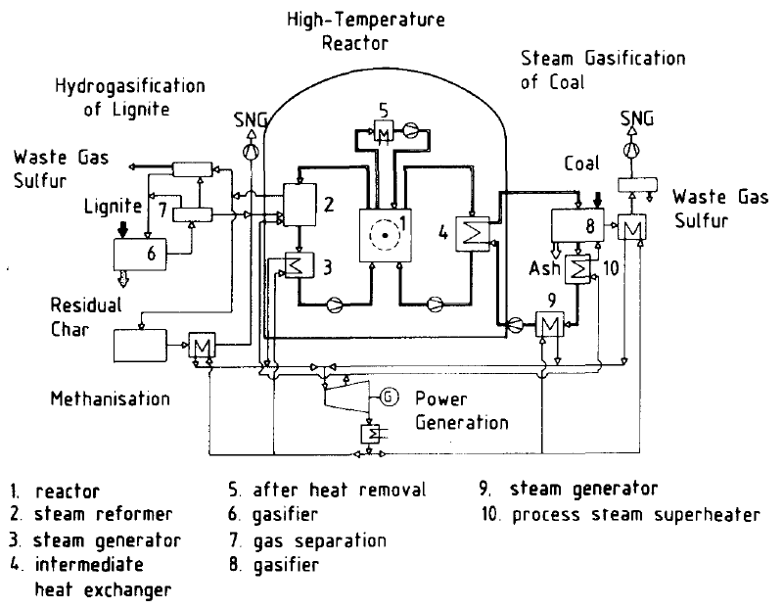Figure 8: general layout of the PNP-500 (ref. 16)

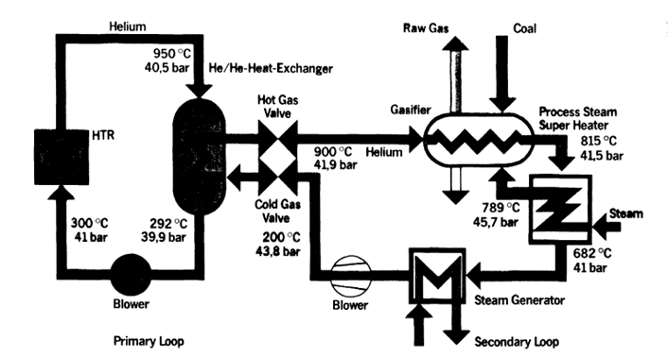

Figure 9: flow sheet of the steam gasification of coal (ref.17)

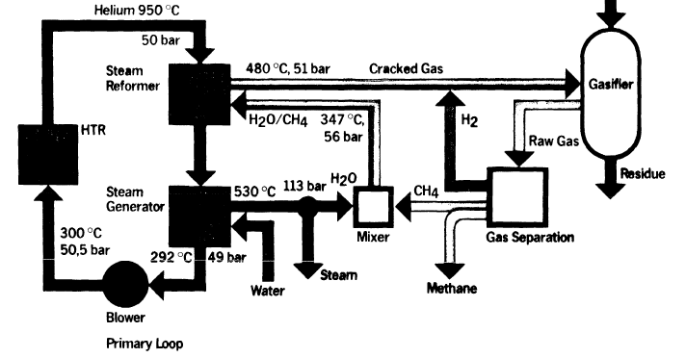

Figure 10: flow sheet of the hydrogasification of lignite (ref.17)
In these applications, nuclear energy is converted into chemically bound energy in the form of gas or liquid (“syngas” or “synfuel”) which can be stored or injected in existing grids.
The safety concept was based on the burst-proof, pre-stressed concrete structure, where the primary components are enclosed in dedicated cavities (i.e. steam reformer, steam generator or intermediate heat exchanger and decay heat removal system) in order to avoid fast depressurization of the primary circuit in any case. The nuclear island was to be buried at least 6 m underground in order to protect it against external hazards (explosion, other kinds of mechanical impacts, etc.). In case of reactor shut down, the process heat production circuits are not used to remove the residual heat. An auxiliary circuit is devoted to decay heat removal. The concrete vessel liner cooling circuit would also be able to cool down the core if the auxiliary circuit was not available (PNP-500 model). Nevertheless, the residual heat of the PNP has to be removed by active cooling systems like for the THTR-300.
Specific risks have arisen from such integrated configuration; which are in particular (ref.16):
- the radioactive contamination of the process gas in case of leaks (with depressurisation of the secondary side),
- release of burnable gases into the containment,
- release of process gas into the primary system,
- process gas explosion close to the plant.
Dedicated R&D and tests program on mockups have been performed to characterize the phenomena associated with the risks listed above and verify the design (ref. 13) and a huge amount of work has been carried out to cope with the above mention risks by determining acceptance criteria and design provisions. Nevertheless, many areas of uncertainties are actually remaining and, today, the licensing of such concepts would lead to long discussions with safety authorities, suppose there would be no regulatory preclusion. However, results obtained with the PNP project should certainly be useful for further cogeneration projects, especially in the field of potential for tritium permeation and analysis of external hazards (ref.13).
Given the risks induced by the process heat conversion as envisaged in the PNP concept, it must be concluded that such concept should be reasonably avoided for a short term project of HTR prototype. Moreover, the fourth generation HTR concept, as promoted within the GIF, relies on passive heat removal.

Process heat and process steam with HTR-Module concept
According to the NC2I-R prospects, the interest lies mainly in cogeneration of electricity and process steam at a temperature below 600°C. The HTR appears to fit well to this aim. So, in the 80s, the deepening of the HTR inherent safety concept after the accident of Three Mile Island, led to a smaller unit design with passive decay heat capability and a PWR-like steel vessel. A modular concept with a thermal power of 200 MWth was then developed by Siemens/INTERATOM, called HTR-Module.

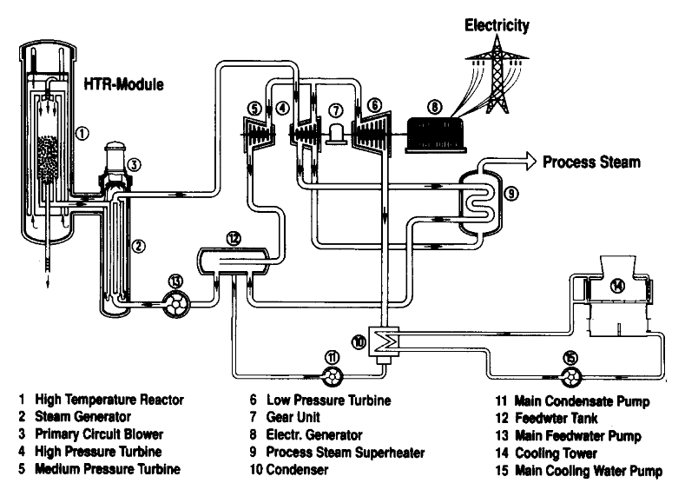

Figure 11: HTR-Module for cogeneration of process steam and electricity (ref.12)
Several adaptations of the HTR-Module have been developed to cope with candidates end-users (see in Table 1). A typical example is the Hanover concept based on the HTR-Module and adapted to deliver steam and electricity to a German oil company (BEB). For this application, the secondary steam was to be extracted from the turbine and directly send to the end-user (see Table 1). This concept has been developed from 1987 to 1990 and underwent licensing procedure on the basis of a safety analysis report submitted in 1987.
The HTR-Module pre-licensing phase and conclusions will be presented in details in the deliverable D3.21. Nevertheless, it is useful to recall some elements of the “safety concept” elaborated for the HTR-module:
- The safety of the plant lies in the demonstration of the robustness of the first barrier (fuel coatings) in any accidental situation of the design basis domain. This is obtained from design specification and experimental qualification of the fuel and not by additional engineered safety systems.
- The large breaks of the second barrier (primary circuit) may be precluded, building on the experience gained with LWRs materials, vessel construction and controls. This eliminates the risk of massive air ingress and early radioactivity release, given that the reactor building has the role to confine long term potential radioactive releases.
- The consequences of accidental water ingress from the secondary circuit are limited by design of the reactor core and vessel.
- Helium coolant continuous purification together with the quality of the fuel ensures very low radioactive impact on the environment of the plant (given the normal helium leakage and releases of gaseous and liquid effluents).
Although a reassessment and some enhancements in the defense in depth approach would be necessary for a new project, the safety features listed above are favorable to a cogeneration application because they reduces the risks of interactions between the nuclear plant and its industrial environment. So the global risk level resulting from the cogeneration may not be higher than the risk level associated with the nuclear plant alone.
According to the designers, the main item discussed during pre-licensing has been the risk of tritium contamination of the process steam because this element permeates through metallic walls. Indeed, tritium migration to the secondary steam and then to the end-products is inevitable, even assuming defect free barriers.
As presented in the ref.13 , the phenomena and physical parameters piloting the tritium migration through the barriers up to the end product have been investigated. In particular, the tritium permeation rates through the tubes of the high temperature steam generators.
For the PNP project involving an intermediate heat exchange circuit, tritium contamination in the hydrogen produced was estimated to be less than 0.37 Bq/g (ref. 4). In this particular case of syngas production, the limit was set to 5 Bq/g by the German Authorities, knowing that the natural radioactivity of the feedstock would already be close to this level. For the HTR-Module producing process steam (without intermediate circuit), tritium concentration has been evaluated to be around 0.49 Bq/g in steady state operation (ref.14). So, according to designers, there were no licensing difficulties regarding the latest German regulation (limit of 5 Bq/g in steady state operation).
One has to note that this report is not a safety analysis of the arguments and evaluations exhibited at the time of the HTR-Module licensing. Whatever the uncertainties which may affect the figure given above, they can be seen as good example to illustrate the order of magnitude of the potential tritium contamination of the process steam. Nowadays, based on these evaluations, it would be necessary to draft a health impact study applicable to a foreseen demonstration plant.
It also important to note that the chemical processes required a lower pressure compared with the usual HTR primary helium pressure. From a safety point of view, in normal operation, the pressure in the secondary circuit has to be managed to keep it always higher than the primary circuit. But the stresses in the heat exchange parts have to be limited anyway. In case of accidental fast depressurization of the primary or secondary circuits, the heat exchange parts (ex. IHX tubes) have to withstand huge increase of mechanical loading, due the pressure difference. Given also the high operating temperature of the heat exchangers, there is a risk of damage of the equipment which is a safety barrier. Thus, an issue was to balance the pressures of primary and secondary. In practice, the PNP project required an adaptation of some physical parameters of the industrial process and of the HTR heat exchange circuits. The primary and secondary pressures were limited to 4 MPa (initial value around 7 MPa). So, unlike with the vast majority of existing co-generation facilities based on PWRs, the foreseen applications based on HTRs would have induced major changes in the nuclear plant operational parameters and, as a consequence, in the safety analysis (as compared with HTRs dedicated to electricity production only).
Regarding the potential for ingress of flammable gases in the building or in the core, the safety assessment would require a careful study of the consequences of the associated accidental scenarios. Installation of a steam reformer in the reactor building would certainly lead to very stringent constraints on its design. Moreover, the presence of flammables gases close to the core, in normal operation, would be hardly acceptable in its principle, as other technical options are available. Furthermore, steam reformers are usually installed in open structures.

Conclusion on HTR feed-back for cogeneration
From the safety point of view, designers have tried to take benefits of the claimed good quality of the first barrier to suppress the intermediate circuit. This is also an advantage to maximize the temperature of the heat carrier fluid.
If process heat production and conversion to chemical energy were envisaged, several specific risks would arise which should require complex analysis, especially to deal with potential external or internal hazards induced (explosion, contamination risk, toxic gases ingress, etc.).
For process steam production, the tritium issue is the main specific concern. Other risks (external events management, load following, bypass management, etc.) appears to be already mastered within the licensing procedures applied to PWRs.

Synthesis

General principles
In general, the decision to build a nuclear plant can be justified if the risks induced (including those associated with the fuel cycle) are balanced by the service rendered by the plant. Following this principle, authorization should be granted for the construction a nuclear cogeneration plant facility if this option would bring obvious advantages over conventional systems. In this frame, safety is a part of an assessment which should encompass the evaluation of risks, environmental footprint and sustainability, so the Authorities would be able to compare the conventional and nuclear options. In practice, it is difficult to quantify all these aspects because, for example, they may change over the life time of the facility.
Thus, for a new plant construction, a solution would be to demonstrate that the implementation of the cogeneration does not impact significantly the risks induced by the nuclear plant: then the question boils down to the “classical” licensing of the nuclear plant.
Furthermore, it is worth arguing on the positive impact of cogeneration on the efficiency of the nuclear plant because this can enhance the ratio of the produced energy over the amount of radioactive waste. Cogeneration helps also reducing CO₂ emissions and the industrial risk associated with the use of oil or gas. As an example, the heat produced at Beznau has saved 8500 truck trips for oil transportation, which has obviously reduced the risk of fire and road accidents.
Regarding the production of process steam, the location of industrial equipment relatively “close” to the nuclear would induce specific risks. At least, it can be stated that the principle of ensuring a “safety distance” shall be applied and industrial equipment should be installed outside the third barrier. However, this principle would require a careful assessment, in particular because the definition of the safety distance has no yet been frozen by the authorities: these elements will be further developed in the D3-2 deliverable of the project.

Feedback synthesis
Water cooled reactors
The review of existing installations has shown that nuclear cogeneration has been developed since the very beginning of civil nuclear development. The nuclear reactors were able to produce low temperature steam (below 250°C), addressing generic needs of district heating and heat intensive applications (paper mills, seawater desalination, etc.). The majority of the existing applications have been developed for district heating.
In practice, the feed-back of existing installations has shown no significant impact on safety of the production of electricity and heat, when using wasted heat or steam bleeding from the secondary circuit, at least up to a certain fraction of the nominal power. The approach relies on the physical decoupling of the heat production and elimination of the risk of heat grid radioactive contamination (see associated provisions in the next paragraph).
Thus, for cogeneration with PWRs, the main safety objective lies in avoiding the release of radioactivity from the primary circuit to the heat delivery circuit. To achieve this objective, simple design provisions and monitoring of the circuits are compliant with the defense in depth principles. In practice, it is to be noted that the NPP reviewed were liable for different safety approaches and provisions, partly because of the large time range of their construction and licensing. Finally, mixing the various requirements on these NPPs, it can be drafted that:
- An intermediate circuit ensures a separation between the primary coolant and the fluid delivered to customers. Steam generators of the primary circuit and heat exchangers of the heat delivery circuit provide two physical barriers.
- The heat delivery circuit may be operated at higher pressure compared to the bleeding points on turbines and this pressure staggering may be monitored.
- The radioactivity of the intermediate circuit must be continuously monitored to be able to detect any abnormal radioactive contamination coming from the primary circuit.
- Isolation devices are implemented on the secondary circuit and on the heat delivery circuit. They can be actuated by the systems monitoring the fluids radiological content and pressures (leak detectors).
As regards the first point above, if barriers are declared for the heat exchangers between secondary and tertiary circuit, it implies that adequate safety class would be adopted and that in service inspection would be performed on this equipment.
Although there are usually some isolation valves implemented on the heat delivery circuit, it must be outlined that they are not linked to a radiological monitoring of the delivered fluid in general. The operators assume that the monitoring of the intermediate circuit is sufficient as secondary heat exchangers or steam generators can be isolated in case of primary fluid leakage (detection). Indeed, for new cogeneration projects, this point should be further reviewed considering the potential for undetected leakage and simultaneous defects affecting the barriers, especially if operation modes could lead to modify temporarily the pressure staggering between the circuits.
For the NPPs reviewed the production of low temperature steam, represents usually a modest proportion of the thermal power of the nuclear plant. Nevertheless, a secondary objective is to avoid a strong feedback of the heat grid load variations on the reactor management. This can be achieved by a combination of:
- the thermal inertia of the grid itself,
- hot water storage,
- back-up installation (gas or oiled fired boilers, etc.).
Nevertheless, from a technical point of view, the NPPs can be operated in a load following mode which allow accommodating the daily heat variation demand as it is done for electricity demand. Adaptation to heat demand needs at least an adequate turbine technology and monitoring, because steam extraction should not degrade the turbine operation, considering in particular steam quality (vapor water weight) and torsional vibrations (load balance between high pressure and low pressure cylinders). As an example, it is easier to achieve load following when live steam is extracted before the turbine. In the examples reviewed, the conventional boilers are used not only as back-up when the NPP is in planned outage but also to manage the peak demand. So, cogeneration would rather help damping the global power variations imposed to the reactor core.
Finally, external hazards potentially induced by the close cogeneration facility are to be assessed (see example of STADE), but it appears not as technical challenge (a priori not different from existing steam generators).
Given these provisions (which are not comprehensively applied in all the installations reviewed in this study), the licensing of a reactor producing low temperature steam is not different from a plant producing only electricity. Thus, for existing plants, it was not worth developing specific safety cases in the safety report. Furthermore, no incidents have been reported to be linked with the NPP associated cogeneration facilities.
The HTR case
The development of high temperature reactors has led the designers to study industrial applications essentially in the field of production of synthetic fuels from coal. This interest appears to have been driven in the 70s by the foreseen difficulties in oil market and the will to leverage European coal resource.
The use of HTR for co-generation is specific because of the high temperature delivered. The coolant fluid between 950°C (maximum) and 600°C can heat up process feed materials and remaining enthalpy can be used to produce steam for electricity production. When comparing the HTR with the above described systems, some of its specificities must be outlined:
- Fission products are efficiently confined in the originally intact fuel particles in every kind of situation (safety paradigm of the HTR).
- The power conversion circuits are not used to remove the residual heat when the reactor is shut down.
- The primary fluid is an inert gas.
- Temperatures of the primary circuit range from 250°C to 750°C or even higher if one consider the former PNP concept (950°C).
- Gaseous coolant pressure is much lower than that of the water-steam circuits.
Past projects have led to an extensive R&D and test program dedicated to the safety issues associated with the coupling. Some scenarios have been investigated, essentially to improve the understanding of physical phenomena and to be able to characterize the associated load cases. But these scenarios have not undergone safety analysis (safety margin analysis, envelope case definition, etc.), and the technical provisions foreseen for reducing the cogeneration specific risks have not been analyzed based on the definition of safety cases. Further discussion on the technical provisions envisaged for the HTR-Modul project will be developed in deliverable D3.2 of the NC2I-R project.
Looking at the examples described above, one has to bear in mind that the heat carrier fluid (steam, helium) or the byproduct (hydrogen, raw gas, etc.) delivered to the end user must be safe. In other terms, the risk of radioactive contamination should be as low as reasonably achievable. According to the designers the tritium issue has been tackled and they claim that very low concentrations are achievable in the heat carrier fluid to be delivered to the customer. A further necessary step for the safety demonstration would be the validation of the technologies for tritium management by mean of a prototype reactor. This would also provide the necessary context validate health and environmental impact studies (product and site dependent).

Conclusion
This paper has provided a tentative analysis of the feedback of nuclear cogeneration, based essentially on European facilities and project plants.
The feedback studied in this report relates to low temperature water/steam production for district heating and industrial use. It must be outlined that the technical feed-back of cogeneration with existing nuclear plant appears positive.
The information collected by the questionnaires was quite scarce regarding the safety procedures and the licensing. At least, it reveals that, according to operators, no cogeneration specific issue was raised during the operation of the nuclear plants.
Although specific safety cases were not presented in the safety reports, safety studies were usually done to demonstrate that the risks induced by the cogeneration installations would not impact the nuclear safety. This was the case for external hazards associated with tertiary installations (turbines, stream generators, etc.) and nearby back-up boilers (see the example of Stade NPP). Impact of the demand variations may have been studied also. Finally, operators demonstrated that they had almost eliminated the risk of radioactive contamination of the heat carrier fluid delivered to customers.
All the above requirements would be examined for a future nuclear cogeneration project.
As regards the HTR compatibility with an industrial process, the plant is to be designed to have a very low potential impact on the neighborhood in any situation (according to designers). This objective is a clear advantage for the coupled system assessment. The coupling scheme envisaged in the past with PNP-3000 project, where flammable gases were produced inside the reactor building and close to the second barrier appears as a challenging configuration which seems no more coherent with present trend in licensing. Accordingly, even if technical provisions might ensure a sufficient prevention and protection of the reactor, the potential economic advantages of this scheme would certainly be jeopardized by the cost of the safety demonstration and subsequent operational constraints (in service inspection, radioprotection, etc.).
In past projects (PNP), the supply of process heat at high temperature through secondary helium has also been envisaged by using an intermediate heat exchanger. A part from technical challenges linked to the IHX design, such application builds on the low radiological contamination of the primary fluid. Specific risks associated with this kind of application will be addressed in the deliverable 3.2. of NC2I-R.
Considering the heat supply through process steam, as envisaged in the applications based on the HTR-Module concept, the pre-licensing procedure of the late 80s provided a significant experience in terms of risk identification. It showed that the production of process steam did not required specific work on licensing, at that time. In other words, standard safety approach would have not been modified to take into account the cogeneration capability of the HTR-Module. This point will be discussed more deeply, together with potential impact of present trends, in the deliverable D3.2 of NC2I-R.
Heat conversion to synthetic fuels should also be investigated for long term applications, considering the possibility to implement the conversion systems at a safety distance from the NPP.
However, it must be stated that the HTR concept exhibits favorable safety features which could allow for a robust safety demonstration regarding the potential consequences in the vicinity and interactions with the industrial environment. In case of coupling with an industrial installation, the hazards induced have yet been characterized in the past. To make a step forward, it would be necessary to determine the specific safety cases to be dealt with in the safety demonstration, taking into account classification against expected frequency and uncertainty analysis.
References
- IAEA TECDOC 1056, Nuclear heat applications: Design aspects and operating experience, Proceedings of four technical meetings held between December 1995 and April 1998, Vienna 1998
- Nuclear district heating plans from Loviisa to Helsinky metropolitan area, H. Tuomisto, Joint IAEA NEA Expert workshop on “Technical and economic assessment of non-electric applications of nuclear energy”, April 2013
- Status of the R&D programme in the field of the heat carrying and heat transfer components of the PNP Project, IAEA, Specialists’ meeting on heat exchange components of gas cooled reactors Düsseldorf, 1984
- IAEA TECDOC 1682, Advances in Nuclear Power Process Heat Applications, Vienna 2012
- 75 MW heat extraction from Beznau nuclear power plant (Switzerland), K.H. Handl, IAEA TECDOC 1056, 1998
- Experience of operating nuclear district heating in Switzerland, R. Schmidiger, Joint NEA/IAEA Expert Workshop on Technical and Economic Assessment of Non-Electric Applications of Nuclear Energy (NUCOGEN), 4-5 April 2013
- The design characteristics and construction experiences of the 5 MWth Nuclear Heating Reactor, Wang Dazhong, Nuclear Engineering and Design 143 (1993) 19-24
- Technical design features and safety analysis of the 200 MWth Nuclear Heating Reactor, Wang Dazhong and al., Nuclear Engineering and design 143 (1993) 1-7
- Halden reactor project, March 30 2011, http://www.ife.no/en/ife/halden/hrp/the-halden-reactor-project/@@relationships/RelAttachment
- Integrated safety assessment of research reactors (INSARR), mission to the Halden boiling water reactor HBWR, Halden Norway, 17-29 June 2007, IAEA-NSNI/INSARR
- Main conclusions and recommendations of the follow-up INSARR Mission to the Halden Boiling Water reactor (HBWR), 6-10 September 2010
- Concept licensing procedure for an HTR-Module nuclear power plant, G. Brinkmann, M. Will, Nuclear Engineering and design 1231 (1990) 293-298
- Technical report experience from PNP-Project at FZJ, G. Brinkmann, D. Vanvor, K. Verfondern, NC2I-RD D2-21, 2014/07/04
- Technical report – Tritium, G. Brinkmann, D. Vanvort, K. Verfondern, NC2I-R, Technical report to deliverables from AREVA GmbH and FZJ, October 2014.
- Nuclear district heating in CMEA countries, V. Soldatov &al., IAEA bulletin, 3/1989
- Safety concept and operational criteria of a nuclear process heat plant, W. Fröhling, and al., Nuclear Engineering and Design 78 (1984) 167 - 177
- Status of the R&D programme in the field of the heat carrying and heat transfer components of the PNP project, IAEA specialists’ meeting on heat exchanging components of gas-cooled reactors, Düsseldorf, April 1984
- Distribution and transport of tritium the Peach Bottom HTGR, R.P. Wichner, F. F. Dyer, ORNL-5497, August 1979
- Is tritium an issue for high temperature reactors? M. A. Fütterer, E. d’Agata, X. Raepsaet, Proceedings of HTR 2014

Acronyms and definitions

Acronym | Definition
EC DG RTD | European Commission – Directorate General for Research and Innovation
HTR | High Temperature Reactor
LWR | Light Water Reactor
PNP  PWR | Prototype Nuclear Process Heat  Pressurized Water Reactor
PHWR | Pressurized Heavy Water Reactor
SFR | Sodium cooled Fast Reactor
NPP | Nuclear Power Plant

APPENDIX I: Extract form the questionnaire on nuclear cogeneration projects – Questions related to safety and licensing

- What were the main steps (safety report, construction permit, etc.) of the licensing of your installation and which were the public authorities involved?
- If cogeneration was implemented after the start-up of the nuclear installation, were additional safety objectives/criteria prescribed, and were specific safety assessments and authorizations from your national authorities required?
- How was the heat production capability taken into account in the safety report of the nuclear installation? In particular, were there any specific initiating events to be considered for the safety assessment, in association with the heat production capability?
- Are there any specific criteria and radiological controls required on the heat transfer fluid coming out of the installation perimeter (or delivered to the end user)?
- Does the cogeneration influence the environmental footprint of the nuclear plant (effluent quantities, heat rejected through the cold source, quantity of steam released to the atmosphere, etc.)?

Turbine which exhaust is directly connected to a condenser (outlet pressure around 0,002 MPa).
Such requirement is mandatory for Russian nuclear district heating facilities.
To complete the questionnaires, the IAEA incident reporting database (https:\\irs.iaea.org) was checked over the last 3 years (accessible archives) and has revealed no incidents potentially linked with co-generation.
However, for future projects, the safety analysis might deal with the potential for radioactive dust release outside the plant, in relation with the confinement strategy.

